Trustee Georgia: Key Vocabulary and Concepts

Georgia did not have a typical government at first. All rules were made by a group of men called the Trustees. Most trustees remained in England.

Trustees COULD:

Trustees COULD NOT:
The Charter of 1732 was valid for 21 years. It set Georgia’s boundaries between the Savannah and Altamaha Rivers. There were three main purposes for Georgia’s colonization:
NOT ALLOWED: WHY?
Land Rules: The trustees wanted a colony of small farms and not large plantations.

*Women were not allowed to inherit land
??

*Colonists could not sell land or use it as collateral.
??

*Mulberry trees must be planted
??

*Males who owned 500 acres had to station a relative or servant on every 50 acres. ??
Charity Colonists Colonists Paying Their Own Way

Settlement

I chose this Situation for the Town upon an high Ground, forty feet perpindicular above High Water Mark; The Soil dry and Sandy, the Water of the River Fresh, Springs comming out from the Sides of the Hills. I pitched upon this Place not only from the Pleasantness of the Situation, but because from the above mentioned and other Signs, I thought it healthy; For it is sheltered from the Western and southern Winds (the worst in this Country) by vast Woods of Pine Trees, many of which are an hundred, and few under seventy feet high. The last and fullest consideration of the Healthfulness of the place was that an Indian nation, who knew the Nature of this Country, chose it for their Habitation.
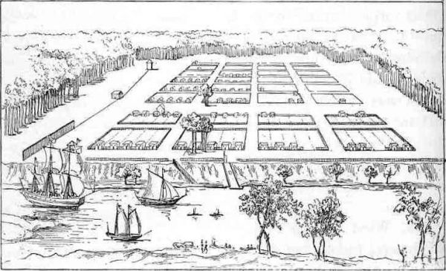
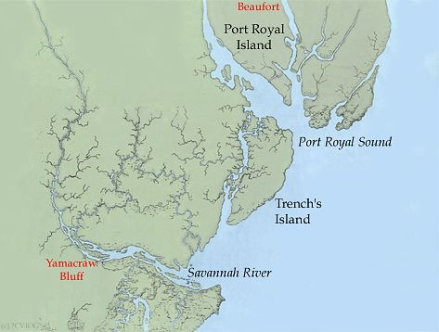
Questions you should be able to answer:

- For what three reasons was Georgia colonized?
- Why did James Oglethorpe want to create a colony for the worthy poor?
- What was the name of the place where Oglethorpe chose to settle? (Two possible answers)
- Why were Tomochichi and Mary Musgrove important people in the initial settlement?
- How did the Trustees ensure no one person would accumulate too much land?
- Who was not allowed in the colony and why?
- How were the rules different for people who came to the colony at the Trustees’ expense and those who paid their own way?
POTENTIAL PROBLEMS?

