Georgia’s Revolutionary Heroes: Mini Speeches

Directions: After researching the lives and Revolutionary-era contributions of each person, create a 1-2 minute speech related to the question for consideration:

Of the six people below, the only person NOT honored with a Georgia county named in his/her honor is Austin Dabney. Should an existing Georgia county be named after Austin Dabney? If so, which county’s name should be replaced and why? If not, why not?

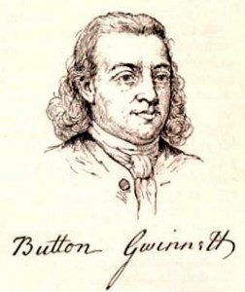
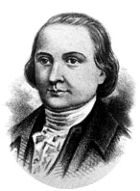
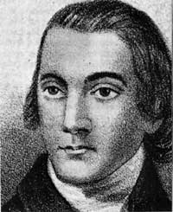

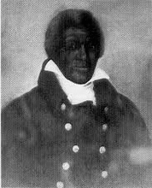
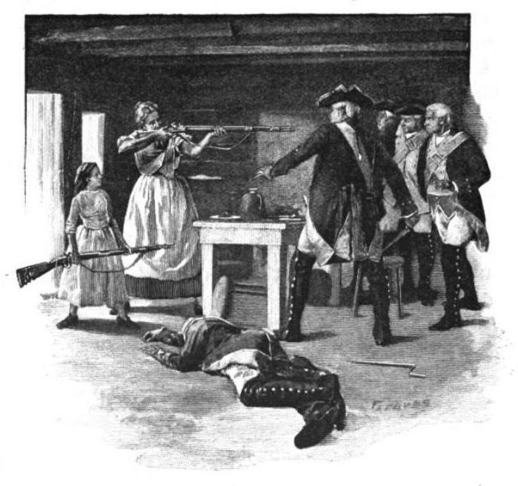
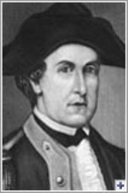

George Walton
Lyman Hall

Austin Dabney
Nancy Hart
Elijah Clarke

