Georgians in the American Revolution: Make the Case

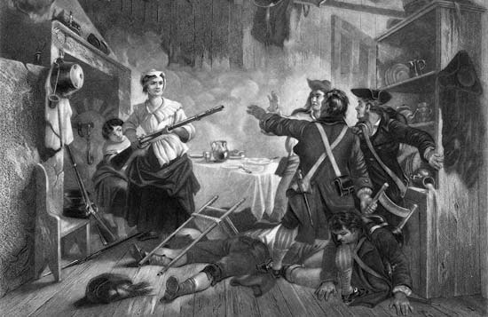
Background:

Elijah Clarke, Nancy Hart, and Austin Dabney are all considered to be prominent Georgians who contributed to the Revolutionary War effort. However, Clarke and Hart are the only two Georgians who are honored with a county in their names.

Question for Consideration:

Should a county be renamed after Austin Dabney? If so, which one? If not, why not?
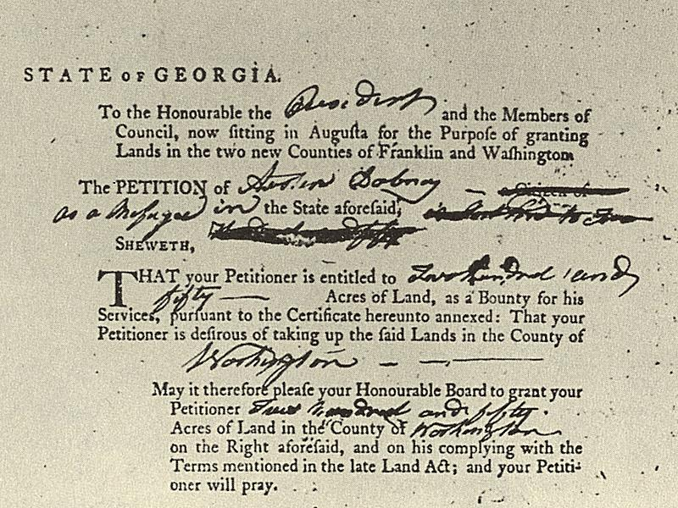
Process: Use the links on the website (www.bestgeorgiastudiesclass.com/ Click “Links”) to gather information about the lives and Revolutionary-era contributions of these three Georgians. Then, consider the question above.

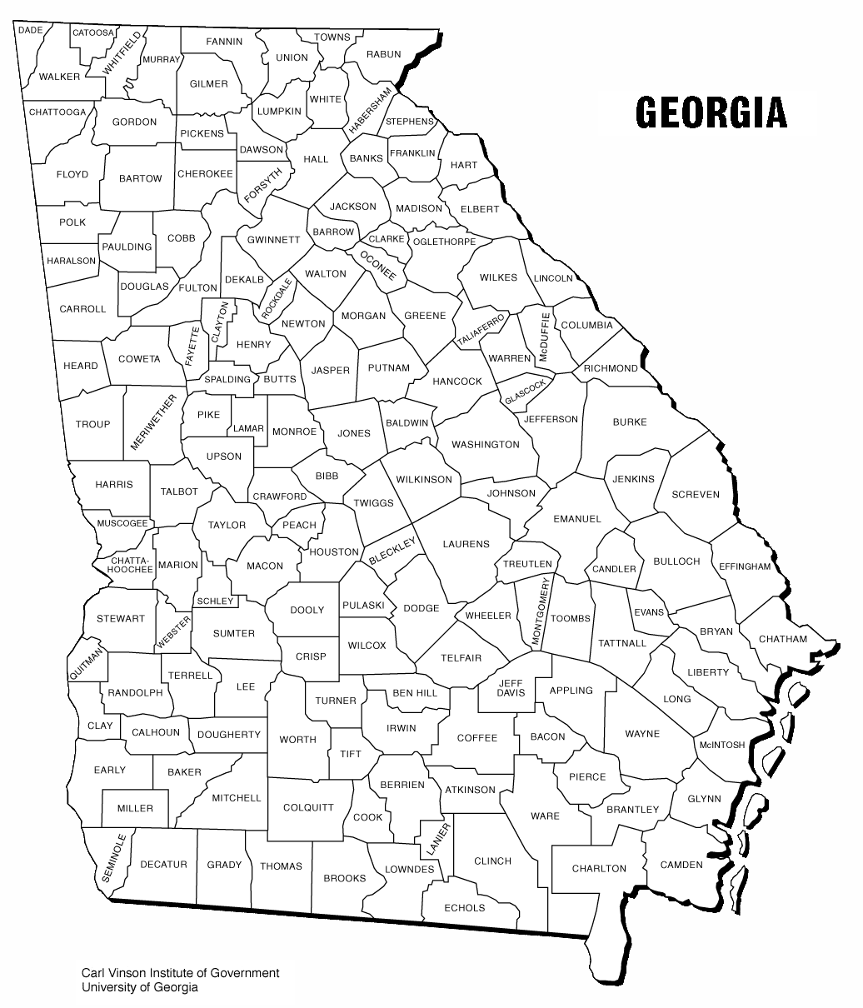
Delivery: We will debate this issue in an upcoming class. Use the chart on the back of this page to record notes. Your notes should be used for guidance in the debate. Your grade will be 60% notes and 40% participation.

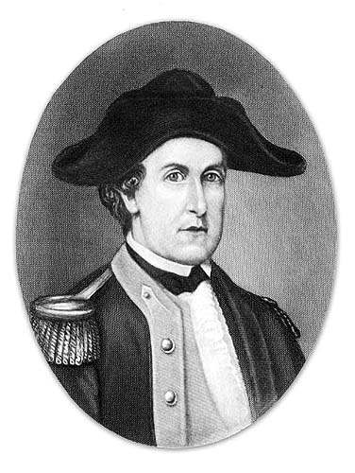

Name | Source 1 | Source 2 | Source 3

My thoughts about the debate question…

