Georgia’s Constitution of 1777

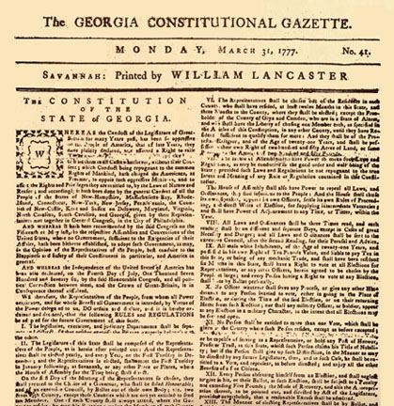
Background: Soon after Georgia accepted the Declaration of Independence, its first state constitutional convention was organized. Completed in February 1777 and approved without having been submitted to voters for ratification, this constitution remained in effect for twelve years.

Excerpts: Annotate for translation (what rights or laws are being created?)

- The legislative, executive, and judiciary departments shall be separate and distinct, so that neither exercise the powers properly belonging to the other.

II.The legislature of this State shall be composed of the representatives of the people; and the representatives shall be elected yearly, and every year, on the first Tuesday in December

III.On the first day of the meeting of the representatives so chosen, they shall proceed to the choice of a governor, and of an executive council, by ballot out of their own body

IV.The house of assembly shall have power to make such laws and regulations as may be conducive to the good order and wellbeing of the State

V.All male white inhabitants, of the age of twenty-one years, and possessed in his own right of ten pounds value, or being of any mechanic trade, and shall have been resident six months in this State, shall have a right to vote at all elections for representatives, and every person having a right to vote at any election shall vote by ballot personally.

VI.The governor shall be chosen annually by ballot, and shall not be eligible to the said office for more than one year out of three, nor shall he hold any military commission under any other State or States.

VII.There shall be established in each county a court, to be called a superior court.

VIII.The jury shall be judges of law, as well as of fact.

IX. Schools shall be erected in each county, and supported at the general expense of the State.

X. All persons whatever shall have the free exercise of their religion; provided it be not repugnant to the peace and safety of the State; and shall not, unless by consent, support any teacher or teachers except those of their own profession.
a.What rights are given?

b.What rights are denied?

c.How does this compare to our current State Constitution?

d.What FEARS are revealed?

XI. Freedom of the press and trial by jury to remain inviolate forever.

XII.Excessive fines shall not be levied, not excessive bail demanded.

XIII.No clergyman of any denomination shall be allowed a seat in the legislature.

