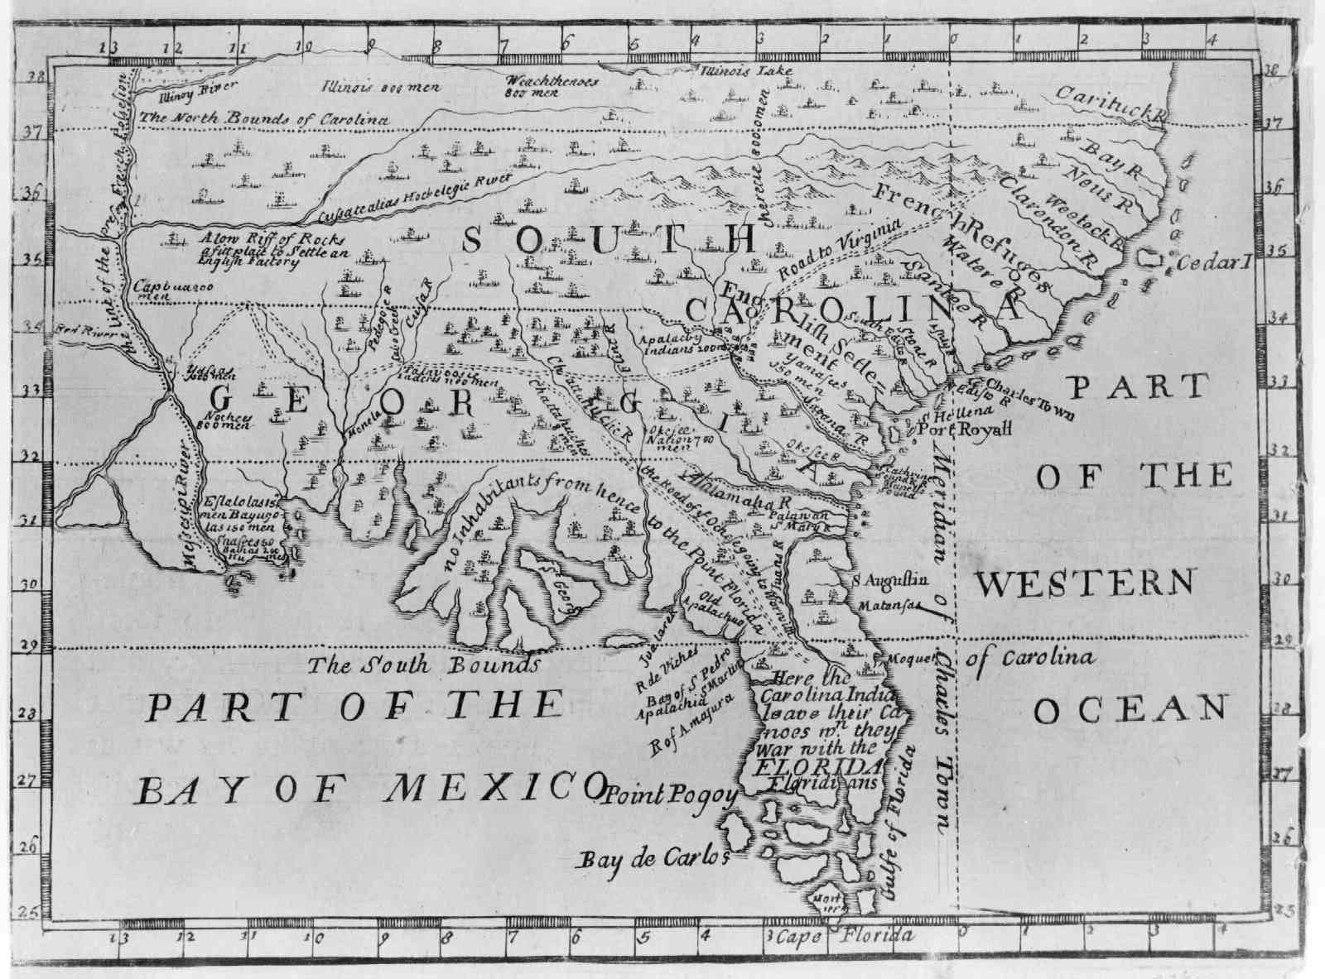

**WHERE:**

*The colony is to be established south of Carolina between the* ***Savannah and Altamaha Rivers.***

*James Oglethorpe who sailed to Georgia on the ship Anne has chosen a site at Yamacraw Bluff. He has begun clearing land for* ***Georgia’s first city which will be named Savannah.***

**Other Rules:**

-No Georgia colonist may sell or inherit land

-Slavery is not allowed

-Families are encouraged to settle here

-Land may not be used as **collateral**

-Lawyers are not allowed

-Jewish settlers are not allowed

-Catholic settlers are not allowed

**Come To Trustee Georgia!**

**WHY?**

1. For **charity**: to help out England’s worthy poor.
2. For **defense**: to protect the rice and indigo plantations of Carolina from the Spanish and the Indians.
3. For **economic** gain. If Great Britain can get all its natural resources from its colonies, it will not have to trade with other countries! This is known as **mercantilism**.

**WHO?**

**Charity Colonists:**

-cannot pay their own way

-**worthy poor**-they are willing to work hard

-get 50 acres of land and a year’s worth of supplies

-must plant mulberry trees for silk production

**Colonists Paying Their Own Way:**

-granted up to 500 acres and a year’s worth of supplies

-must station a male 18 y/o or older on every 50 acres

-Must plant mulberry trees for silk production

**WHAT?**

King George II wrote the Charter of 1732 which gave the Trustees permission to settle the colony. The Trustees have 21 years to run the colony and make it work according to plan.