The Constitutional Convention

Location: Philadelphia, PA Dates: May-September, 1787 Purpose: Revise the Articles of Confederation

Participation: 12 of 13 States Georgia’s Delegates: Abraham Baldwin and William Few

Solution:
Solution:

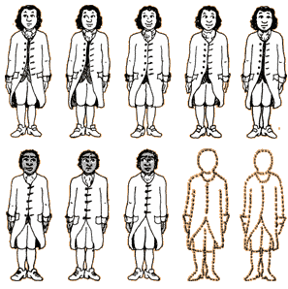
Solution:
PROBLEM:

The LEGISLATIVE BRANCH

More populated states wanted representation based on population.

Lesser populated states wanted equal representation.
PROBLEM: SLAVERY

Southern states wanted slaves counted as part of their population. That would equal more representation.

Northern states argued that slaves were considered property, and shouldn’t be counted toward population.
PROBLEM: BILL OF RIGHTS

Federalists argued having a list of rights would limit people’s rights to ONLY what was on the list.

Antifederalists argued a list of rights was the only way the people could be protected from a tyrannical government.

